*A Micro*

*-*

*Project Report*

*On*

“ CASNIo Guess , DIGITAL CLOCK ”

Submitted on

*By*

1.

**Taheer Shaikh**

2.

**Mahimkar Saad**

Under Guidance of

**Trapti Soni Mam**

*In*

Three

Years

Diploma

Program

in

Engineering

&

Technology

of

Maharashtra

State

Board of

Technical

Education,

Mumbai

(

Autonomous

)

ISO

9001:2015

*At*

**Anjuman**

**-**

**I**

**-**

**Islam’s Abdul Razzaq Kalsekar Polytechnic**

**Academic Year [ 20**

**-**

**20**

**]**



|  |
| --- |
| **MAHARASHTRA STATE BOARD OF TECHNICAL**  **EDUCATION, MUMBAI**    ***Certificate***  This is to certify that Mr. /Ms./Mrs.  Enrollment No: of  **Semester** of **Diploma in Computer**  **Engineering** at **Anjuman I Islam’s Abdul Razzak Kalsekar Polytechnic,** has completed the **Micro Project** satisfactorily in Subject in the academic year 20 - 20 as per the MSBTE prescribed curriculum of I Scheme.        Place: Enrollment No:      Date: / /2022 Exam Seat No:            **Project Guide Head of the Department Principal**      Head    of    Institute |
| **MAHARASHTRA STATE BOARD OF TECHNICAL**  **EDUCATION, MUMBAI**    ***Certificate***  This is to certify that Mr. /Ms./Mrs.  Enrollment No: of  **Semester** of **Diploma in Computer**  **Engineering** at **Anjuman I Islam’s Abdul Razzak Kalsekar Polytechnic,** has completed the **Micro Project** satisfactorily in Subject in the academic year 20 - 20 as per the MSBTE prescribed curriculum of I Scheme.        Place: Enrollment No:      Date: / /2022 Exam Seat No:            **Project Guide Head of the Department Principal**      Head    of    Institute |

INDEX

|  |  |
| --- | --- |
| SR.NO | TOPIC |
| 1 | FRONT PAGE |
| 2 | CERTIFICATE |
| 3 | INDEX |
| 4 | CODE |
| 5 | FLOWCHART  ALGORITHM |
| 6 | INFORMATION |
| 7 | CONCLUSION |
| 8 | REFERENCE |

* **CASINO CODE**

#include <iostream>

#include <string> // Needed to use strings

#include <cstdlib> // Needed to use random numbers

#include <ctime>

using namespace std;

void rules();

int main()

{

string playerName;

int balance; // stores player's balance

int bettingAmount;

int guess;

int dice; // stores the random number

char choice;

srand(time(0)); // "Seed" the random generator

cout << "\n\t\t========WELCOME TO CASINO WORLD=======\n\n";

cout << "\n\nWhat's your Name : ";

getline(cin, playerName);

cout << "\n\nEnter the starting balance to play game : $";

cin >> balance;

do

{

system("cls");

rules();

cout << "\n\nYour current balance is $ " << balance << "\n";

// Get player's betting balance

do

{

cout << "Hey, " << playerName<<", enter amount to bet : $";

cin >> bettingAmount;

if(bettingAmount > balance)

cout << "Betting balance can't be more than current balance!\n"

<<"\nRe-enter balance\n ";

}while(bettingAmount > balance);

// Get player's numbers

do

{

cout << "Guess any betting number between 1 & 10 :";

cin >> guess;

if(guess <= 0 || guess > 10)

cout << "\nNumber should be between 1 to 10\n"

<<"Re-enter number:\n ";

}while(guess <= 0 || guess > 10);

dice = rand()%10 + 1;

if(dice == guess)

{

cout << "\n\nYou are in luck!! You have won Rs." << bettingAmount * 10;

balance = balance + bettingAmount * 10;

}

else

{

cout << "Oops, better luck next time !! You lost $ "<< bettingAmount <<"\n";

balance = balance - bettingAmount;

}

cout << "\nThe winning number was : " << dice <<"\n";

cout << "\n"<<playerName<<", You have balance of $ " << balance << "\n";

if(balance == 0)

{

cout << "You have no money to play ";

break;

}

cout << "\n\n-->Do you want to play again (y/n)? ";

cin >> choice;

}while(choice =='Y'|| choice=='y');

cout << "\n\n\n";

cout << "\n\nThanks for playing the game. Your balance is $ " << balance << "\n\n";

return 0;

}

void rules()

{

system("cls");

cout << "\t\t======CASINO NUMBER GUESSING RULES!======\n";

cout << "\t1. Choose a number between 1 to 10\n";

cout << "\t2. Winner gets 10 times of the money bet\n";

cout << "\t3. Wrong bet, and you lose the amount you bet\n\n";

}

**OUTPUT**

======CASINO NUMBER GUESSING RULES!======

1. Choose a number between 1 to 10

2. Winner gets 10 times of the money bet

3. Wrong bet, and you lose the amount you bet

Your current balance is $ 500

Hey, SAAD, enter amount to bet : $50

Guess any betting number between 1 & 10 :5

Oops, better luck next time !! You lost $ 50

The winning number was : 3

SAAD, You have balance of $ 450

-->Do you want to play again (y/n)? y

* **FLOWCHART OF CASINO**

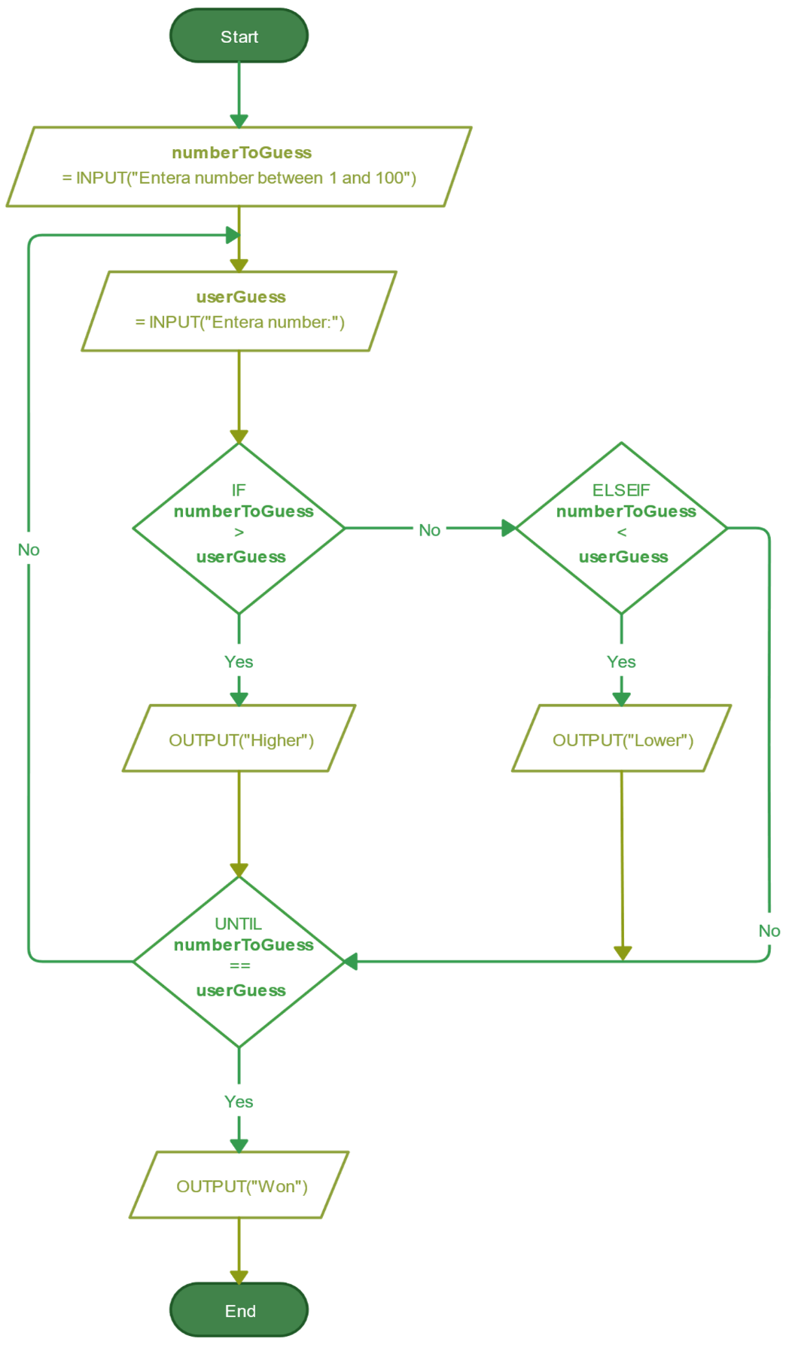

* **ALGORITHM OF CASINO**

1. Start

2. Read variables Playername,Amount

3. do Read Bettingamount while(choice==y||choice==n)

4. if Bettingamount>Amount read guess [ICITAIC-2019] ISSN 2348 – 8034 Impact Factor- 5.070 (C)Global Journal Of Engineering Science And Researches 310 dice=rand()%10 + 1 else Display re-enter the Bettingamount

5. if guess=Diceamount Amount=Bettingamount*10 else Amount=Amount- Bettingamount

6. Repeat steps 3,4,5 7.Stop

* **INFORMATION OF CASINO**

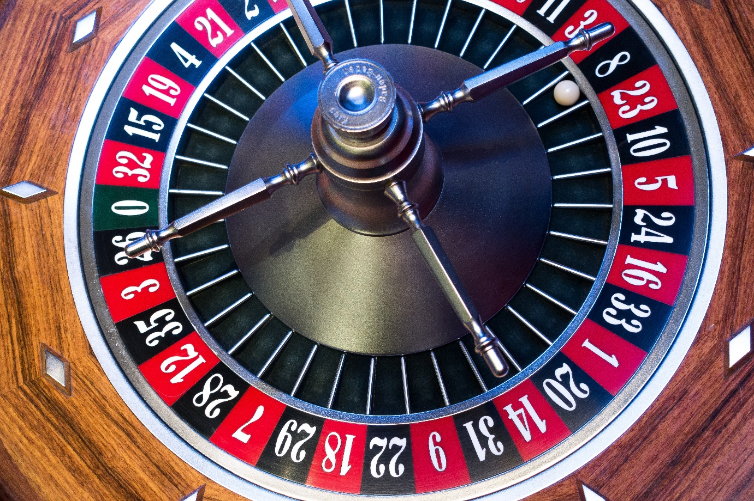

Casino is a Number Guessing Game. Player deposits an initial amount to start playing game. He guesses a number between 1 to 10 and enters betting amount. If he wins he will get 10 times of money he bets. If he bets on wrong number he will lost his betting amount. Game continues till user wants to play. [ICITAIC-2019] ISSN 2348 – 8034 Impact Factor- 5.070 (C)Global Journal Of Engineering Science And Researches 309 There are three general categories of casino games: table games, electronic gaming machines, and random number ticket games such as keno. Gaming machines, such as slot machines and pachinko, are usually played by one player at a time and do not require the involvement of casino employees to play. Random number games are based upon the selection of random numbers, either from a computerized random number generator or from other gaming equipment. Random number games may be played at a table, such as roulette, or through the purchase of paper tickets or cards, such as keno or bingo. Casino games generally provide a predictable long-term advantage to the casino, or "house", while offering the player the possibility of a large short-term payout. Some casino games have a skill element, where the player makes decisions; such games are called "random with a tactical element". While it is possible through skillful play to minimize the house advantage, it is extremely rare that a player has sufficient skill to completely eliminate his inherent long-term disadvantage (the house edge or vigorish) in a casino game. Such a skill set would involve years of training, an extraordinary memory and numeracy, and/or acute visual or even aural observation, as in the case of wheel clocking in roulette or other examples of advantage play. The luck factor in a casino game is quantified using standard deviations (SD). As the number of rounds increases, eventually, the expected loss will exceed the standard deviation, many times over.

* ***CONCLUSION***
* *Thus we completed microproject on CASINO NUMBER GUESS*
* ***REFERENCE***
* *Google*
* *Youtube*

* **DIGITAL CLOCK CODE**

#include <iomanip>

#include <iostream>

#include <stdlib.h>

#include <windows.h>

using namespace std;

// Driver Code

int main()

{

system("color 4A");

// Background color and Foreground

int hour, min, sec;

cout << setw(70)

<< "*Enter Current time*\n";

// Use of manipulator for taking

// input from the user

cout << "HH- ";

cin >> hour;

cout << "MM- ";

cin >> min;

cout << "SS- ";

cin >> sec;

// Background color and the

// Foreground for 2nd screen

system("color 4A");

// Cases for the Wrong Time Input

if (hour > 23) {

cout << "Wrong Time input";

}

else if (min > 60) {

cout << "Wrong Time Input";

}

else if (sec > 60) {

cout << "Wrong Time Input";

}

// Otherwise

else {

while (1)

// Run Block infinitely

{

system("cls");

// Clear the console

// Code for Showing Time

for (hour; hour < 24; hour++) {

for (min; min < 60; min++) {

for (sec; sec < 60; sec++) {

system("cls");

cout << "\n\n\n\n~~~~~~~~~"

"~~~~~~~~~~~~~~~~~~~~~"

"~~~~~~~~~~~~~~~~~~"

"Current Time = "

<< hour << ":" << min << ":"

<< sec

<< "Hrs~~~~~~~~~~~~~~~~~~"

"~~~~~~~~~~~~~~~~~~~~~"

"~~~~~~~~~";

// HH:MM:SS columns in output

Sleep(1000);

// Pause for 1 sec

}

sec = 0;

}

min = 0;

}

}

}

}

**OUTPUT**

*Enter Current time*

HH- 18

MM- 14

SS- 02

Current timing 18:14:02

* **FLOWCHART OF DIGITAL CLOCK**

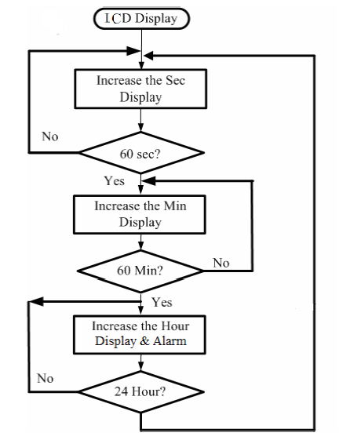

* **ALGORITHM OF DIGITAL CLOCK**

* **INFORMATION OF DIGITAL CLOCK**

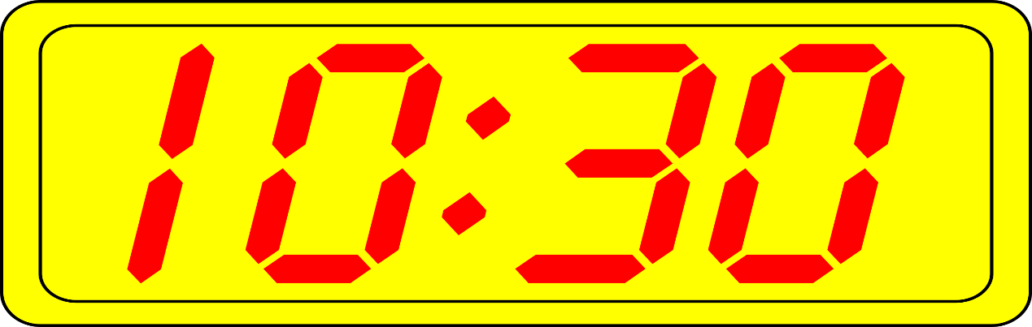

Create a screen that will show “Current time” of your location which will be implemented using simple output methods used in C++ i.e., cout, and a manipulator “setw()“.

In the fore mentioned screen, implement the HH column, MM column, SS column, that will contain the time.

Implement colors using System(“color 4A”), the color will be in hexadecimal format and the console can be used to implement them using double-digit hex codes (0 to F) which will, in turn, change the text color in the console of the output.

In the last screen, a digital clock can be seen finally implemented and running from the inputted time.

* ***CONCLUSION***
* *Thus we completed microproject on DIGITAL CLOCK*
* ***REFERENCE***
* *Google*
* *Youtube*
* ***DEVICE SPECIFICATIONS***

*Processor: AMD Ryzen 5 3400G with Radeon Vega Graphics 3.70 GHz*

*Installed RAM: 8.00 GB (5.95 GB usable)*

*System type: 64-bit operating system, x64-based processor*

*Pen and touch: No pen or touch input is available for this display*

*Edition: Windows 10 Pro*

*Version: 22H2*

*Experience: Windows Feature Experience Pack 120.2212.4180.0*

*THANK YOU*